GRADE 6 SCIENCE AND TECHNOLOGY LESSON NOTES

LIVING THINGS
- The term living thing refers to things that are now or once were alive
- A living thing pertains to any organism or a life form that possesses or shows the characteristics of life or being alive

PLANTS
- Plants are living things.
- The grouping of plants together with common characteristics or features is called the classification of plants.

TYPES OF PLANTS
Identifying different types of plants
Pupil’s activity Page 1

To observe the different types of plants
Pupil’s activity Page 1

To identify different types of plants found in the locality
Pupil’s activity Page 2-3

Types of plants found in the locality
- Trees
- Are big plants
- They have single stem called trunk and many strong branches
- Examples of tress include mango, coconut and avocado trees

- Shrubs
- Are shorter than tress
- They have many thin and woody stems
- Examples of shrubs include hibiscus, rose and cotton plants

- Shrubs
- Are small plants with soft green stems
- Examples of herbs include mint and coriander

- Grass
- Is short and has narrow leaves

Parts of a plant
Identifying different parts of a plant
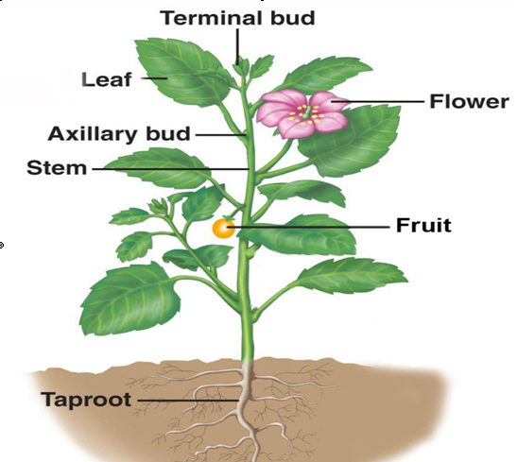

To name different parts of a plant
Pupil’s activity Page 3

To identify different parts of plants growing in the environment
Pupil’s activity Page 3-4

To draw different parts of a plant
Pupil’s activity Page 5
- The external parts of a plant include
  - Roots
  - Stem
  - Leaves
  - Flowers
  - Fruits 6.

Functions of different parts of a plant
To discuss the functions of different parts of a plant Pupil’s activity
Page 6
Part of a plant | Function
Leaves
Stem
Fruits
Seeds
Flowers

Functions of the roots
- Support/hold/anchor the plant firmly in the soil
The roots absorb water and mineral salts from soil through a process called absorption Plants need water and mineral salts for proper growth

- Absorption of water and mineral salts
The roots hold the plants firmly in the soil
This ensures that the plants are not carried away by water or wind

- Food storage
Some plants such as arrowroots, cassava and carrots store food in the roots

Functions of the stem Stem –
- Transports water and mineral salts from the roots to the leaves Carries food made by the leaves to the roots for storage
- Holds or supports the upper parts of the plant in good position
- Protects the plant
- Storage of water- some plants such as a cactus store water in the stem
- Some stems store food and water for the plant
N.B. Plants that store food in the stem are called stem tubers. Examples of plants that store food in the stem are: a) Cactus b) Sugar cane c) Irish potato

To investigate the absorption and transport of water and mineral salts in a plant
Pupil’s activity Page 7-8

Functions of the leaves
- Breathing – Exchange of gases through small tiny holes called stomata.

- Manufacture of food
Leaves make food for the plant using chlorophyll, sunlight, water and carbon (IV) oxide through a process called Photosynthesis – Process of making its own food Requirements of photosynthesis are:- Chlorophyll – green colouring matter Water Carbon dioxide Sunlight

- Storage of food – Edible vegetables such as kales, cabbages, spinach

- Removal of excess water through transpiration
Transpiration – Process in which plants lose excess water through small holes called stomata. Transpiration is high when it is hot, sunny, dry, windy. It is low when it’s cold, wet, calm and rainy.

Function of flowers
- Flowers are the reproductive organs of plants
- They develop into fruits
- It bears fruits which contains seeds that germinate into a new plant Seeds germinate into new young plants called seedlings

Function of fruits
- Storage of food
Some plants like avocados, mangos and orange store food in fruits
- Protecting seeds
In most plants, seeds are found inside fruits The fruits protect the seeds from drying

Functions of seeds
When seeds germinate, they grow into new plants

To investigate transpiration in plants
Pupil’s activity Page 9

Making mounts of plants
Pupils activities Page 10-11

TYPES OF ROOTS
There are two main types of roots
- Tap root - extension of stem with side roots
- Fibrous roots-many similar roots

To observe taproots and fibrous roots
- Pupil’s activity Page 13
- To collect plants with different types of roots
- Pupil’s activity Page 13

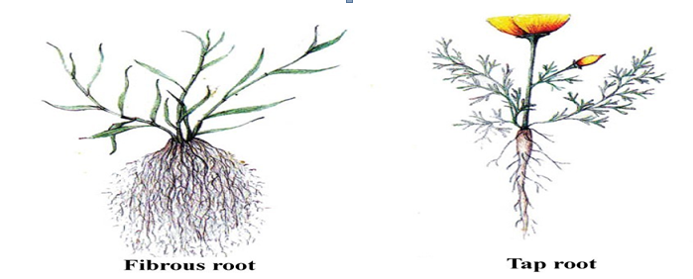

Taproots | Fibrous roots
They consist of one main root that grows down into the soil  They have lateral roots that arise from the main root | They do not have a main root  All roots are similar and they arise from the same place
They grow deep into the soil | They are shallow
They grow vertically downwards into soil | They grow horizontally in all directions
Plants with tap roots include:-  Legumes, Acacia, Fruit trees, | Plants with fiirous roots include:- Cereals, Oats, Grass, Sisal, Onions, Sugarcane,  Coconuts

Grouping plants based on the type of roots they have
Pupil’s activity Page 16

Other types of roots
Other types of roots include:
- Aerial roots – for breathing
- Prop roots – used in maize for support

To mount different types of roots
Pupil’s activity Page 17 -18

ANIMALS
Invertebrates

Categorizing invertebrates
Animals are classifiee into 2 main groups that is:-
  - Vertebrates.
  - Invertebrates.

Invertebrate
Are animals without backbone Examples
- Bees
- Flies
- Grasshopper
- Earthworm
- Lobster
- Snail
- Millipeee
- Fleas
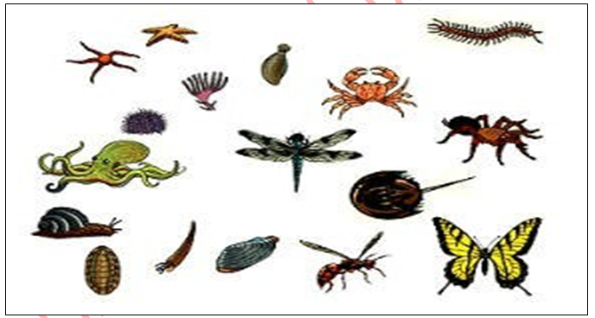

Safety precautions to observe while handling invertebrates
Pupil’s activity Page 22-23
- Do not touch the invertebrates. Some can sting or produce substances that can irritate the skin
- Do not kill the invertebrates
- Do not destroy the areas where the invertebrates live
- Do not remove the invertebrates from where they live 5.

Identifying invertebrates found in the locality
Pupil’s activity Page 23-24

To observe and identify invertebrates
Pupil’s activity Page 23-24

Name of the invertebrate | Where it was found
1.
2.
3.
4.
5.
6.
7.

Characteristics of different invertebrates
To discuss the characteristics of invertebrates
Pupil’s activity Page 25

Name of the  invertebrate | Number  of wings | Number  of legs | Number of  feelers | Number of  eyes | How it moves
1.
2.
3.
4.
5.

To observe the characteristics of invertebrates
Pupil’s activity Page 2

Name of the insect | Number  of body parts | Number of wings | Number of legs | Number ofantenannae | How it moves
1. Louse
2. bees
3. butterflies
4. termites
5. mosquito

Characteristics of insects

- Insects have 3 body parts 1. Head, 2. Thorax, 3. Abdomen
- Insects have 3 pairs of legs
- Most insects have 2 pairs of wings. They use the wing for flying
Some insects such as beetles and ants do not have wings
- Insects have a pair of antennae on top of their heads.
Antennae are also known as feelers
Antennae are long, thin and are used for sensing.
- The body of an insect has a hard covering called exoskeleton 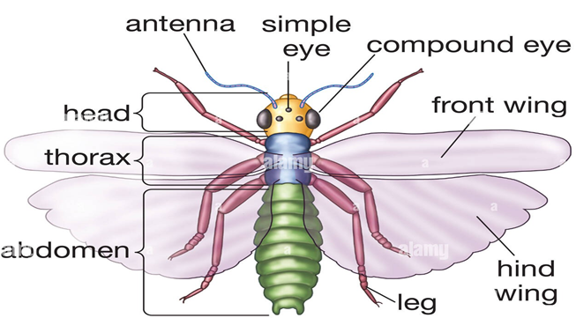
Characteristics of spiders and ticks

To discuss the characteristics of spiders and tick
Pupil’s activity Page 28-29
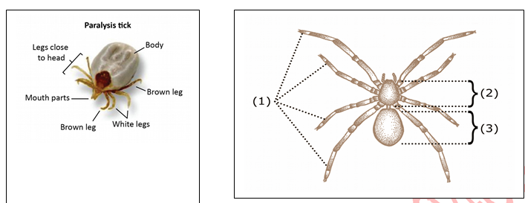

- Spiders and ticks have 2 body parts
- Spiders and ticks have 4 pairs of legs
- Spiders and ticks do not have wings
- Spiders and ticks do not have antennae

Characteristics of snails and slugs
To discuss characteristics of snails and slugs
Pupil’s activity Page 29-30

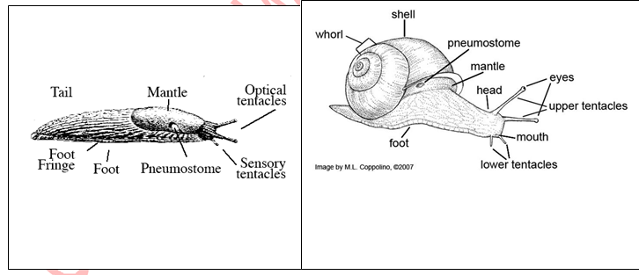

- Snails and slugs have soft body
- Snails and slugs do not have wings
- Snails and slugs have 2 pairs of feelers on their heads. The feelers are also called receptacles
- Snails and slays move by crawling on slimy mucus using the muscular foot The slimy mucus is produced by muscular foot
Snails have shells while slugs do not have shells.

Characteristics of centipedes and millipedes
To discuss characteristics of centiiedes and milliiedes
Pupil’s activity Page 30-31

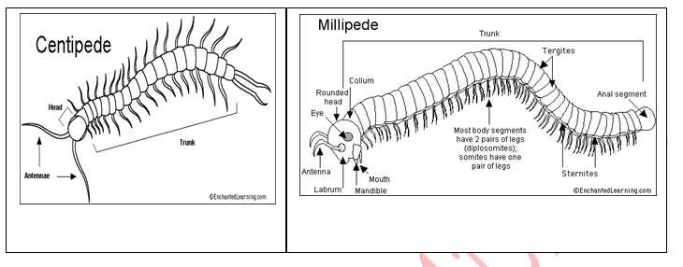

- Centipedes and miillipedes 㿨aie 2 bodty sections- 㿨ead and iruuns
- T㿨e iruuns of boi㿨 miillipedes and centipedes is diiide inio mianty sections called segment
- Centipedes and miillipedes 㿨aie mianty pairus of legs.

- Centipedes 㿨aie one pairu of legs peru segmieni, one leg on eac㿨 side of i㿨e bodty.
- Millipedes have two pairs of legs per segment.
- The legs are positioned under the body
- Millipedes coil body when disturbed

- Centipedes have one pair of antennae on the head

Importance of invertebrates to human beings
- Source of food
Some insects such as termites are used as food by some people Bees produce honey which is used as food

- Pollination
Most flowering plants are pollinated by insects Pollination enables to produce seeds

- Cleaning the environment
Some invertebrates such as millipede feed on decaying matter turning it into compost. This helps to clean up the environment
The compost makes soil good for growing crops
NB Some invertebrates are harmful to human beings

Making a photo album of invertebrates in the locality
Pupil’s activity Page 32-33

HUMAN CIRCULATORY SYSTEM
- Blood circulates throughout the body in a system known as the circulatory system
- The heart, blood and the blood vessel make up the circulatory system
- The heart is a muscular organ that pumps blood to all parts of the body. Blood circulates around the body in blood vessels
- Blood is a body fluid that is used in the transportation of substances within the body.
- Blood vessels are tubes in which blood flows
The main blood vessels are the arteries, veins and capillaries

Main Parts of Human Circulatory System
- The circulatory system is important because it is involved in the transport of the following substances in the body.
  - Oxygen from the lungs to all parts of the body
  - Digested food from the small intestines to all parts of the body
  - Carbon dioxide from the body to the lungs where it is breathed out.
  - Heat from the liver to all parts of the body. This helps to regulate body temperature
Waste products from different parts of the body to organs such as kidneys to be removed from the body
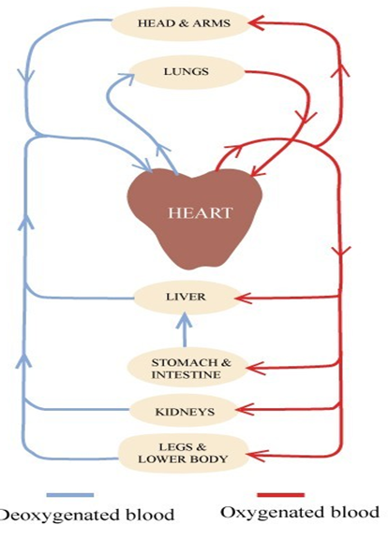

Parts of the heart and their functions
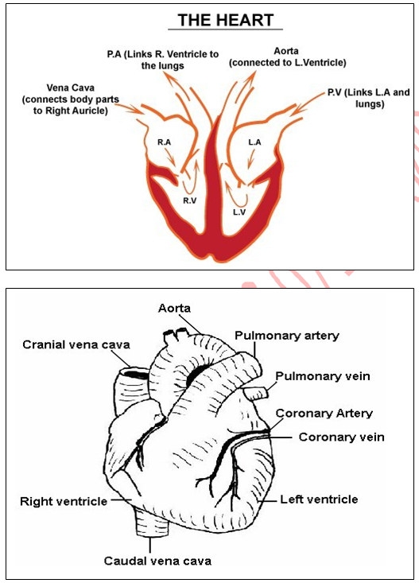

Parts of the heart and their functions

HEART - This is the organ that pumps blood throughout the body. It is muscular and placed between the lungs somewhere slightly to the left side of the body. The strong muscles of the heart can relax or contract when contracting the heart pumps blood with force. When the heart relaxes, the blood flows into chambers of the heart
15
- The heart has 4 chambers.
- The upper chambers are known as auricles and the lower chambers are known as

ventricles.
- The heart has 2 auricles, the left auricle and the right auricle and 2 ventricles and the
right ventricle and the left ventricle.
- Auricle have thinner walls than ventricles
- The function of the heart is to pump blood to all parts of the body
- Auricles receive blood from body organs and then empty it into the ventricles.
- The ventricles then pump blood to the lungs and to other parts of the body
- The heart has valves that prevent blood from flowing backwards

The heart is connected to blood vessels Pumping of the heart
- The right auricle receives blood from the body The blood then flows into the right ventricle
This blood does not have oxygen and is called deoxygenated blood
- The right ventricle pumps the deoxygenated blood into the left into lungs through the pulmonary artery.
In lungs, the blood receives oxygen and becomes oxygenated blood.
- The oxygenated blood flows from the lungs into the left auricle of the heart through the pulmonary vein
The blood then flows into the left ventricle
- The left ventricle then pumps the oxygenated blood to all parts of the body(except the lungs) through the aorta
The left ventricle has thick muscular walls because they pump blood to all parts of the body
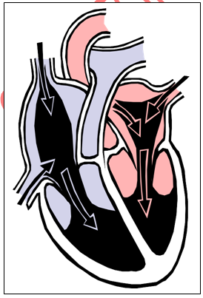
- The heart has valves which prevent blood from flowing backwards

Types of blood vessels and their functions Blood vessels are tubes that carry blood around the body. The main blood vessels in the body are
- Arteries
- Capillaries
- Veins

Arteries
- Arteries have thick elastic walls
- Arteries have a narrow lumen
Lumen is the space inside a tube such as a blood vessel
- Arteries carry blood away from the heart to the parts f the body
- Arteries carry oxygenated blood except the pulmonary artery which carries deoxygenated blood from the heart to the lungs
- Blood in arteries flow under high pressure because it is pumped from the heart into the arteries at high pressure.
This high pressure can be felt in the arteries as a beat.
We can determine the number of times the heart beats in a minute by counting the beats in the arteries
The number of times the heart beat in a minute is called a pulse or a beat rate. The pulse is easiest to find on the wrist and on the neck.
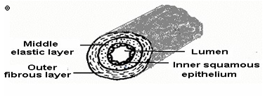

To check the pulse at the wrist
Pupil’s activity Page 41-42
Name | Pulse at rest | Pulse after jumping
1.
2.
3.
4.
5.
NB: the pulse increased after jumping
- The pulse rate of a healthy person at rest is between 60-100 beats per minute
- Pulse increased during an activity

- This because during activity, the body needs more oxygen and so the heart pumps blood faster to supply the body with more oxygen.

17

Veins
- Veins have thin walls
- Veins have a wide lumen
- Veins have valves to ensure blood flows only in one direction
- Veins carry blood towards the heart
- Veins carry deoxygenated blood except the pulmonary vein that carries oxygenated blood from the lungs to the heart.

Valve A shows a vein with open valve to allow blood to pass through it while valve B shows a vein with closed valve to prevent blood from flowing backwards

Capillaries
- Capillaries have very thin walls
- Capillaries have no valves
- Capillaries reach every part of the body.
They allow movements of oxygen and food nutrients from blood into the body.
They also allow the movement of carbon dioxide and other wastes from the body into the blood
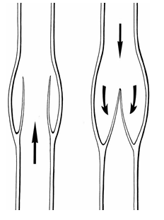

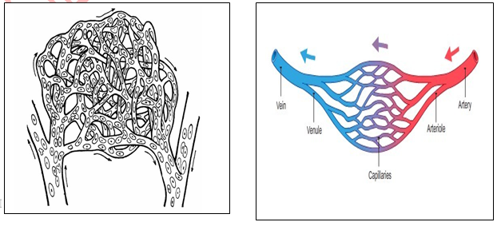

Difference between arteries, veins and capillaries

Arteries | Veins | Capillaries
Have thick elastic walls, | Have thin walls and elastic, | Have thin walls
Have no valves | Have valves | Involved in the exchange of substances between blood  and body organs
Carry blood away from the  heart |  | Are very narrow,
 |  | Form network in every organ and tissue

Components of blood and their functions

To find out the components of blood
Pupil’s activity Page 43-44

To study the components of blood
Pupil’s activity Page 44

BLOOD COMPONENTS AND THEIR FUNCTIONS
The four main components of blood are:
- Plasma
- Red blood cells
- White blood cells
- Platelets

Plasma
It is the liquid part that forms the main part of the blood It is mostly pale yellow.
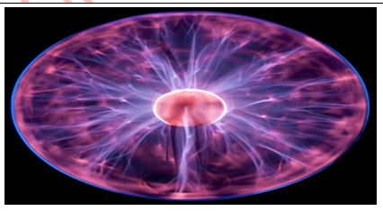
It contains dissolved substances e.g. digested food, salts, amino acids and glucose.

Functions Plasma
Transportation of:
- Digested food from the ileum to all parts of the body.
- Oxygen from the lungs to all body tissues.
- Carbon dioxide from body cells to the lungs to be expelled.
- Waste products to the organs of excretion.
- Heat from the liver to all parts of the body.
- Hormones from the glands to where they are needed.
- Other blood components e.g. white blood cells, red blood cells and platelets to where they are needed

Red blood cells
-Biconcave in shape.
- Contain haemoglobin (Red colouring matter).
- Have nucleus which disappears on maturity.
- Produced in red bone marrow
- Destroyed (broken) in the liver/spleen.
- Red blood cells carry oxygen from the lungs to the body tissues.
- Oxygen combines with haemoglobin to form oxyhaemoglobin –oxygenated blood, which is bright red in colour (dark red)

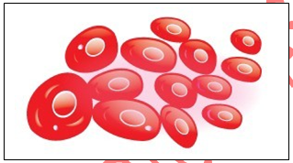
White blood cells
- Larger than red blood cells
- Few in number compared to red blood cells i.e. ratio of white to red blood cells is 1:600
- Have no definite shape- they change their shape easily
- Have a nucleus at the centre
- Produced in the yellow bone marrow and the lymph glands
N.B. White blood cells fight and kill germs by engulfing them.

Platelets
  - They are tiny oval shaped cells
  - They are found in plasma
  - Help the blood to clot when injured.
  - They prevent further loss of the blood from the part that was injured. They help to stop bleeding from cuts and wounds.

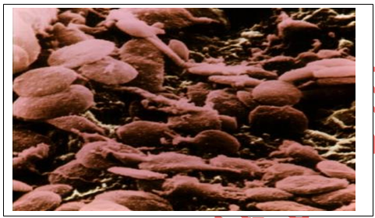

Blood groups
  - Blood group is the type of blood a person has.
  - The ABO blood group system is one of the ways of grouping blood.
  - In the ABO blood group system, there are 4 main blood groups
  - These are
- Blood group A
- Blood group B
- Blood group AB
- Blood group O

Blood transfusion
  - It is the process by which blood from one person is added to another person
  - The person who gives blood is called donor.
  - The person who receives blood is known as recipient.
  - Blood transfusion is done to help restore blood in people who have lost a lot of blood due to injuries or disease
  - Before a blood transfusion is done it is important to know the blood group of both donor and the recipient.
  - This is to ensure that compatible, that is it can mix without the red blood calls clumping together (agglutination) in the receipt’s body.
  - Clumping together of red blood cells can be dangerous

Compatibility of blood group

 | CAN DONATE TO | CAN RECEIVE FROM
Blood group A | Blood group A and AB | Blood group A and blood  group O
Blood group B | Blood group B and blood group AB | Blood group B and Blood  group O
Blood group AB | Blood group AB | All groups
Blood group O | All groups | Blood group o

Compatibility of blood groups

- A person with blood group O can donate blood to people of all the other blood groups.
People with blood group O are referred to as universal donor
- A person with blood group AB can receive blood from all the blood groups and is therefore referred to as universal recipient.

To make models of different components of blood
Pupil’s activity Page 48-49

REPRODUCTIVE SYSTEMS
Living things have organs that enable them to reproduce. These organs form the reproductive system
This part presents two kinds of reproductive system, namely female and male reproductive systems.

Parts and functions of the female reproductive system
To discuss the parts and functions of the female productive system
Pupil’s activity Page 50-51

The system by which human beings are enabled to produce young ones is called female
reproductive system. The system consists of different parts. These include:
- Vagina
- Cervix
- Uterus
- Ovaries and
- Fallopian tubes.
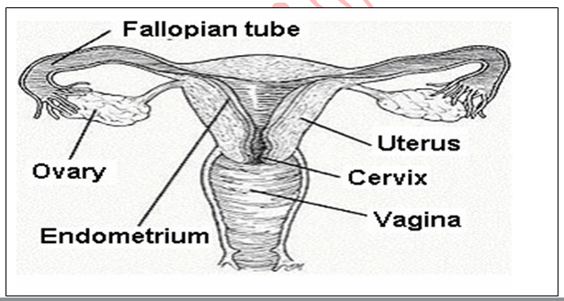

Definition and functions of the major parts of the female reproductive system

Ovary
- They are mall oval shaped glands that are located on either side of the uterus
- They produce egg cells called ova in a process called ovulation. When released the eggs enter into the oviduct

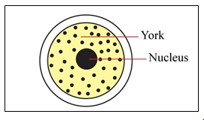
- They produce hormones

Oviduct
  - Also called fallopian tube
  - The oviduct is a tube that connects the ovary to the uterus
  - It is the place where fertilization of the egg by the sperm takes place

Uterus
- Also known as womb
- The place where the fertilized egg develops into a foetus

Cervix
- It connects the vagina with the uterus
- It produces mucus that facilitates the entry of sperms
- It opens to allow passage of a baby from the uterus into the vagina during childbirth

Vagina
- Also known as birth canal
- It is an elastic tube that extends from the vaginal opening (vulva) to the cervix
- It receives semen during intercourse
- It is the birth canal through which the body passes during birth

Parts and function of the male reproductive system
To discuss the parts and functions of the male reproductive system
Pupil’s activity Page 52-53

Male Reproductive System consists of various parts. These include
- Penis
- Testis
- urethra,
- Gland – Prostate gland, seminal vesicles and the Cowper’s gland
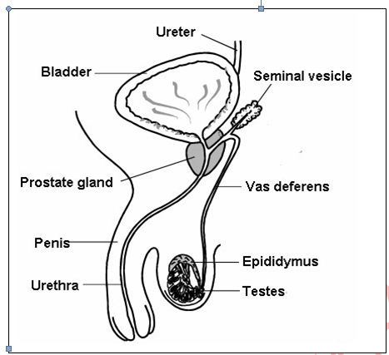

Definition and functions of the major parts of the male reproductive system
- Penis
- It is the male sex organ
- Tube like structure through which sperms are released
- It transfers sperm into the female reproductive system during intercourse
- Also in this structure urine is passed outside the body.

Testicle or testis/testes
- Testis is oval shaped and is enclosed within a structure called scrotum which hangs outside the body
- Testis produces sperms and hormones

Urethra
- The urethra is a tube that runs through the penis
- It is a passage of sperms and urine out of the body

- Gland
- The glands produce a fluid as seminal fluid
- Sperm cells depend on seminal fluid to move and to keep them alive
- The mixture of seminal fluid and sperm is called semen

Sperm duct
- A tube that allows the sperm to pass from testis to the urethra

Physical changes that occur during adolescence
- The period in a persons’ life when developing from a child into an adult is referred to as adolescence.
- The stage is usually between the age of 12 and 19 years.
- During this time many changes take place in terms of growth and physical changes.
- Physical changes are changes that are visible
- The boy or girl who is undergoing this change is called adolescent

Physical Changes in Boys during adolescence
- Broader chest and shoulders
- Breaking voice to become deeper
- The penis, testes and scrotum enlarge
- Growing of hair in part of the body (around sex organs, pubic hair, chest hair, beards on the face and armpits.
- Sperms mature in the testis experiences ejaculation, which is release of sperms through penis. At times this can happen during the night and is called wet dreams.
- Boys eat more because height and weight are increasing and becoming muscular
- At times development of pimples on the face may occur

Physical Changes in Girls during adolescence
- Growth of breasts
- Hair grows in the armpits and around sex organs(pubic hair)
- Hips become broader,
- Release an egg by ovaries after 28 days (ovulation). This happens if the egg(ovum) is not fertilized. The lining that had been formed in the uterus along with the egg breaks down and flows out of the body through vagina as blood. This process is called menstruation. It occurs once a month and may last 4-5 days,
- Pimples may appear on the face
- Rapid increase of weight and heights and may cause them to eat more

NB: Apart from physical changes, adolescents undergo other changes that affect their feelings and behaviour towards other people.
These changes are known as emotional changes
EMOTIONAL CHANGES IN BOTH GIRLS AND BOYS
Moods: Hormones lead to mood changes that an adolescent cannot explain.
This might bring misunderstanding between the adolescent and other people. They become unreasonably aggressive, angry, easily disappointed etc.
Shyness: Girls feel shy about their enlarging breasts or pimples on their face. Boys are shy about their cracking voice.
Embarrassment: Girls are embarrassed about their menstrual flow. Boys about their wet dreams
Unhappy: Boys and girls feel unhappy with the size and shape of their bodies.
Worry: Both tend to worry about their appearance, especially when pimples develop on the face, a condition known as Acne.
Girls who start their menstrual flow late or have small breasts tend to worry about themselves. They may feel abnormal.

Social implications of changes that occur during adolescence
- Development of new identity
This makes adolescent try out new clothing styles, listen to new music and develop new friendships all in a bid to behave like adults
- Development of values
This makes adolescent question things.
They therefore seem like they are rebelling against established rules
- Desire for independence
This makes adolescents want to make their own decisions like how to spend their free time or how to spend their money
- Increased peer influence
This influences adolescent’s behaviour and mode of dressing Adolescents want to be important and recognised by their friends
- Development of interest in the other gender leading to relationships
- Increased influence from media. The internet greatly influences adolescents

Health implications of changes that occur during adolescents
- Sexually transmitted infections (STI) and diseases usually pass from one person to another through sexual contact
AIDS, Syphilis and Gonorrhoea are some of examples of sexually transmitted infections
- Adolescents need to practise good hygiene fo their well being and for those around them
- Teenage pregnancy can increased health risks for newborns as well as for the young mothers
- The use of alcohol and other drugs can lead to addition, failure in school and poor judgement which may put adolescents at risk of accidents and suicide
- Adolescents are encouraged to share their feelings when they feel overwhelmed.

ENVIRONMENT
WATER CONSERVATION

MEANING OF WATER CONSERVATION
Conservation of water means the proper care and use of water and water sources. Conserving water ensures it’s spared for future use.

To discuss the meaning of water conservation
Pupil’s activity Page 61

Ways of conserving water

To find out how water is conserved in the locality
Pupil’s activity Page 62

WAYS OF CONSERVING WATER
- Harvesting rainwater
- Recycling the use of water
- Re-using
- Using water sparingly
- Mulching/shading
- Storing water in dams/constructions of dams
- Reducing the use of water

REUSING
  - Reusing water means using water that has already used
  - Water which has already been used can be used for another purpose
  - The following are some ways in which water can be reused
- Water used to wash clothes can be used to flush the toilet, cleaning houses
- Water used for cleaning fruits and vegetables can be used again for watering crops on the farm
- Water used for washing clothes can be sprinkled on earthen floors to reduce dust
- Water used for washing hands can be used to mop floors

